**Independent vs Mutually Exclusive events.**

Independent event means both the events are independent of each other and doesn’t matter if A has occurred or not or B has occurred or not.

Means in P(A|B) = P(A) ,i.e., Even if we know that B has occurred it doesn’t affect the happening of event A

For example:

P(“Raining today”| “Rained Yesterday”) = P(“Raining today”)

So even if it rained yesterday we cant say that it will rain or it will not rain today so both the events are independent of each other.

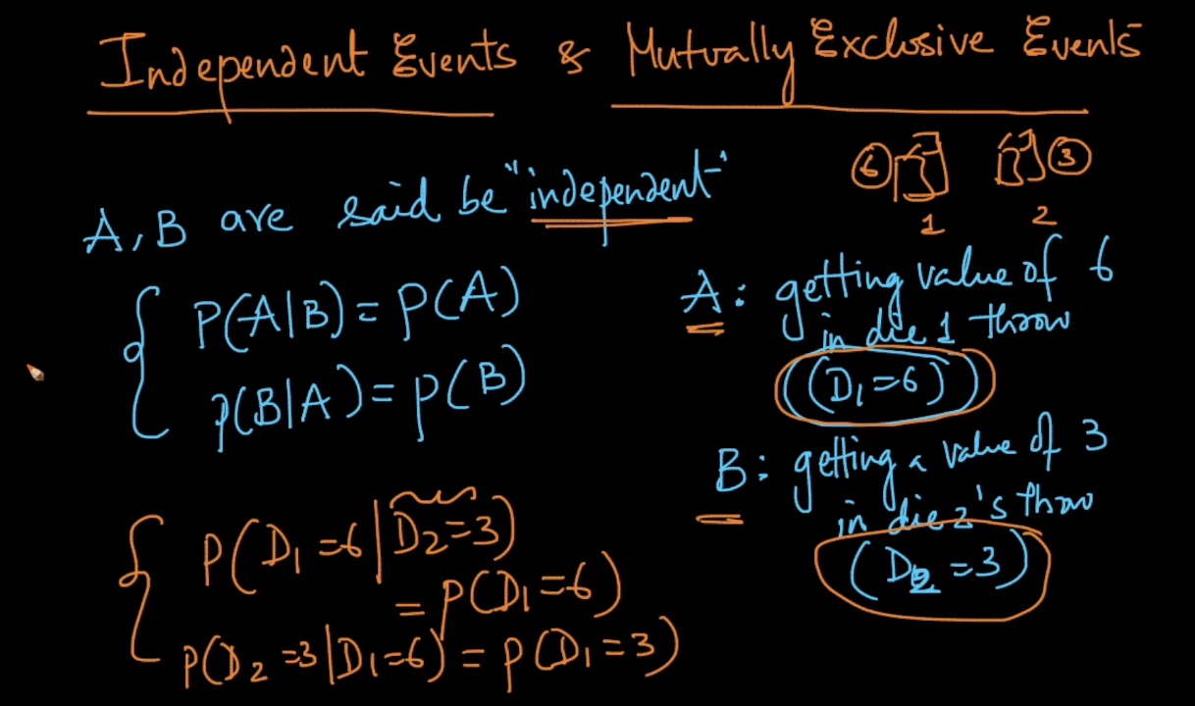

IN above image we have taken example of rolling two dice simultaneously and so P(D1= 6|D2=3) = P(D1 = 6) because even if we know that second dice will land as 3 it is not going to affect the probability of D1 = 6 .

That means both the events are independent of each other and so we can not say D1 will land as 6 even if we know that D2 has landed as 3.

Now lets discuss the concept of Mutually exclusive event :

It means if are given that event B has occurred P(A) is 0.

i.e., P(A and B) = 0 {and is intersection}.

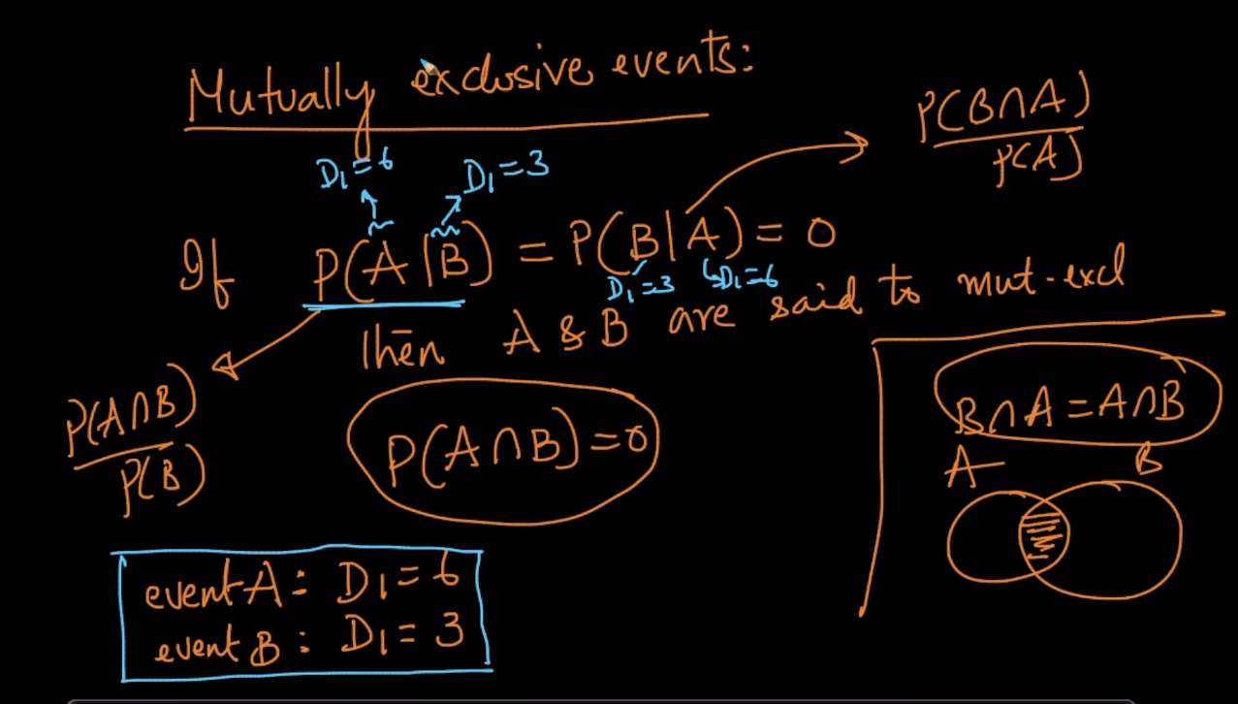

Lets take and example:

Event A is India have won the match

Event B is India have lost the match

SO what is P(A|B) = P(India won the match | India lost the match)

So when we try to read it in English what is mean is that we know that India has lost the match so what is the probability of India’s Winning , it is 0 offcourse.

This is what mutually exclusive means.

**LINKS:**

https://www.mathsisfun.com/data/probability-events-independent.html  
https://www.mathsisfun.com/data/probability-events-mutually-exclusive.html